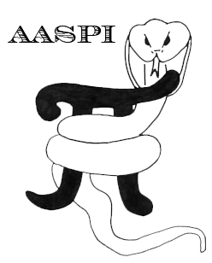

Machine Learning Applications using Seismic Attributes – A Hands-On Course

Part 5d: Attribute Selection using Gaussian Mixture Models and Random Forest Decision Trees

AASPI Lab Exercises written by:
David Lubo-Robles
Thang Ha
Jie Qi
Yuji Kim
Kurt J. Marfurt

The University of Oklahoma

Contents
Gaussian Mixture Models (GMM) and Generative Topographic Maps (GTM) – AASPI Program attribute_selection 2
Overview of Gaussian Mixture Models (GMM) 4
Implementation 5
Attribute Selection 6
Measuring the Cumulative Distance between Seismic Facies 7
Attribute selection results 11
Random Forest Decision Tree Classification– AASPI Program rfc3d 17
Single decision tree and random forests 18
Feature importance 18
References 22

Gaussian Mixture Models (GMM) and Generative Topographic Maps (GTM) – AASPI Program attribute_selection

Interpreters face two main challenges in seismic facies analysis. The first challenge is for a human interpreter to define, or “label”, the facies of interest. Accurately defining the 3D extent of a given seismic facies takes an understanding of geologic processes and the limits of seismic acquisition, processing, and imaging. Machines learning is based on accurate training data, which in this application is provided by a skilled interpreter defining polygons about facies of interest. The second challenge is to select a suite of attributes that can differentiate a target facies from the background reflectivity. Unfortunately, there are relatively few interpreters who possess both a deep understanding of the geology of a given exploration play and a deep understanding of the sensitivity of an ever-expanding collection of seismic attributes to geology.

This GMM-based attribute selection program is a tool to select best attribute combinations from input candidate attributes. The GMMs use PDFs to represent rather than to discriminate between facies. Gaussian mixture models are based on probability theory, and by construction provide a posterior probability that any particular voxel belongs to a given mixture model.

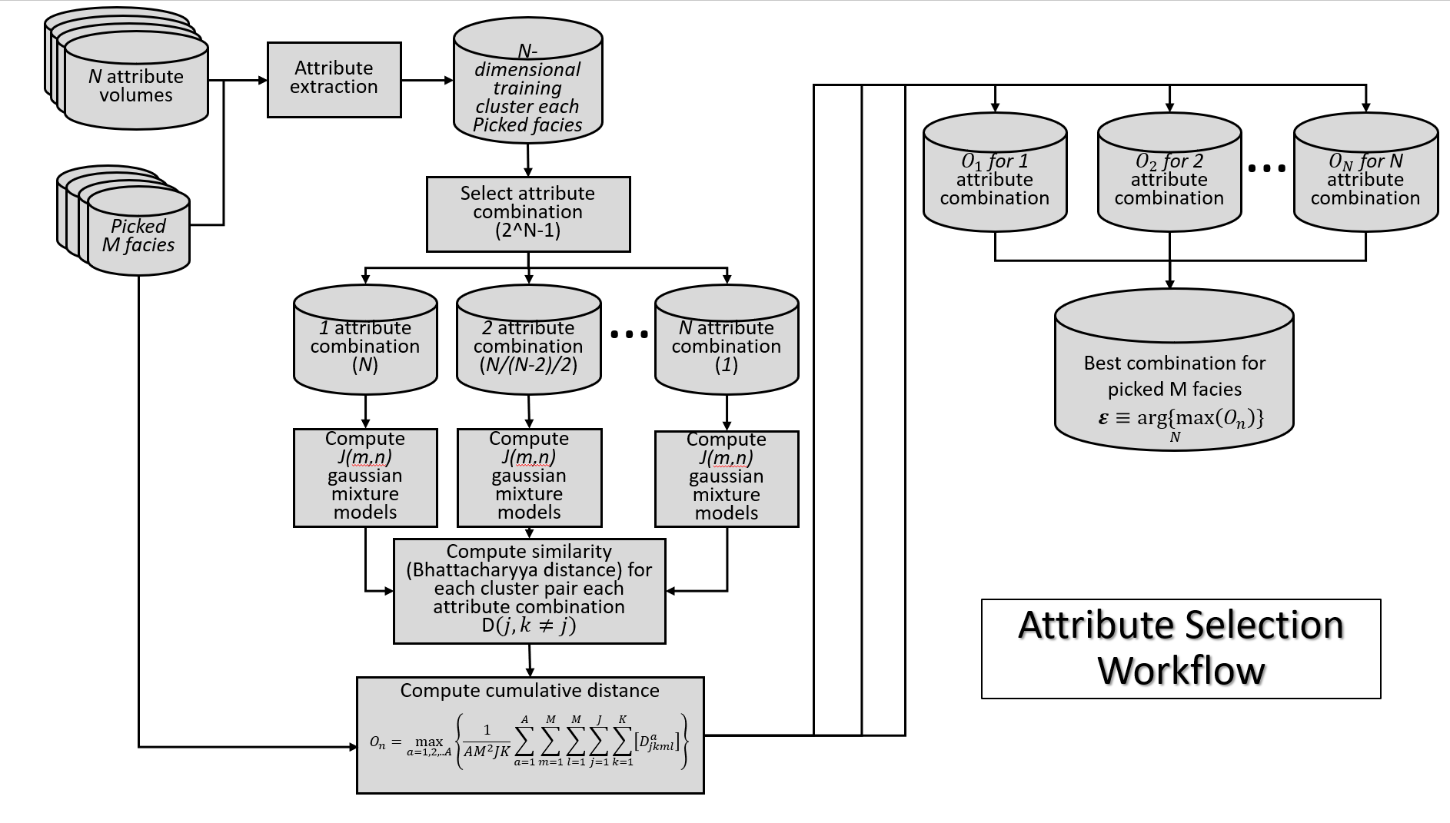

Workflow illustrating the steps used in our GMM-based attribute selection process. The workflow starts with an interpreter defining polygons around the facies of interest on a coarse grid of vertical and time slices. Attribute values falling within voxels enclosed within these polygons are then extracted for each of the N candidate attributes forming the training data. The GMM clusters are computed for each facies each attribute combination. Then, the Bhattacharyya distance is computed for each cluster pair that is in the same attribute dimension. The winning attribute combination in each attribute dimension needs to calculate the average cumulative distance for the comparison of attribute combinations that are in different attribute dimensions. The best attribute combination is the one has the highest average cumulative distance.

The program attribute_selection is launched from the Volumetric Classification in the main aaspi_util GUI.

We pick facies of interest by drawing multiple polygons on a seismic amplitude volume. The candidate seismic attributes are selected based on interpreter’s experience. The training voxels are then extracted on the picked polygons from all candidate seismic attributes. Next, we compute GMM clusters for each picked facies each possible attribute combination, then compute the Bhattacharyya distance to measure the similarity between each cluster under the attribute combinations that are in the same dimension of attribute space. The higher the Bhattacharyya distance between each facies cluster indicates the more easily the pair of clusters are separable.
To evaluate attribute combinations between different dimension space, we define the average cumulative distance. In different number of attribute spaces, there is one optimum attribute combination, and the attribute combination that has the highest average cumulative distance is the best combination among all possible attribute combinations.

First, we filter the selected seismic attributes using a 3D adaptive Kuwahara filter to suppress effects of seismic noise, smooth interior textures, and sharpen the edges of seismic facies. The filtered attributes are then mapped onto the GTM latent space to generate unsupervised PDFs of all voxels. The picked voxels of each facies associated with the selected attributes are then mapped onto the latent space to generate supervised PDFs of training voxels. Then, we compute the likelihood between training and all voxels, which results in probability volume of training facies.

To define seismic facies, we need to use the module define_training_data module, which is launched from the Volumetric Classification in the main aaspi_util GUI.

Overview of Gaussian Mixture Models (GMM)

The GMMs use PDFs to represent rather than to discriminate between facies. Gaussian mixture models are based on probability theory, and by construction provide a posterior probability that any particular voxel belongs to a given mixture model. In statistics, a multivariate distribution of data vector $x_{i}$ on the parameters $ψ$ modeled by Gaussian mixture models is:

$p\left(x_{i} | ψ\right)=\sum_{k=1}^{K}{φ_{k}f}\left(x_{i} | μ_{k},Σ_{k}\right)$, (1)

where $μ_{k}$ is the mean and $Σ_{k}$is the covariance matrix for the multivariate case. $φ_{k}$ is the weight, which is given by:
$\sum_{k=1}^{K}{φ_{k}}=1$. (2)

The multi-dimensional Gaussian mixture probability function is
$f\left(x_{i} | μ_{k},Σ_{k}\right)=\frac{1}{{\left|Σ_{k}\right|}^{\frac{1}{2}}{\left(2π\right)}^{\frac{N}{2}}}exp\left(-\frac{1}{2}\left(x-μ_{k}\right)Σ^{-1}{\left(x-μ_{k}\right)}^{T}\right)$, (3)

where the symbol ^{T} indicates transpose of a matrix. N is the number of candidate attribute, where i=1 … N. In n-dimensional attribute space, the kth PDF is defined by its mean $μ_{k}$ and its covariance matrix, $Σ_{k}$. Hardisty (2017) show how to compute the optimum number of GMMs to represent multiattribute data in a seismic survey, where the objective is to determine if different seismic facies naturally clump into different areas of n-dimensional space, allowing them to be color-coded and displayed.

Implementation
Following Wallet and Hardisty (2019), we will use the k-means clustering to generate initial clustering models. We apply 300 iterations of a refinement technique to cluster attribute vectors into an attribute space defined by the first two eigenvectors of N-by-N covariance matrix. Thus, k-means technique results the initial multivariate means $μ_{k}^{i}$ and the covariance matrices $Σ_{k}^{i}$, and the weights $φ_{k}^{i}$ is defined by the fraction of attribute vectors assigned to each k-means cluster. Because the number of component K is known, expectation maximization (EM) is able to use to determine the best model’s parameters. Classification Expectation-Maximization (CEM) as an alternative EM algorithm is better to classify data vectors, when data vectors are assumed to be generalized into a single Gaussian mixture model (Celeux and Govaert, 1992; Hardisty, 2017). K-means clustering is a popular cluster analysis for data mining, which is able to find clusters of comparable spatial extent. In general, Expectation-maximization algorithm for mixture Gaussian distributions involves both K-means and Gaussian mixture models. The conjunction of the Classification Expectation-Maximization (CEM) and the Stochastic Expectation-Maximization (SEM) is employed to learn mixture parameters in this paper. Like the conventional EM algorithm, both two algorithms require to define a partition of the input data, then compute the posterior probability according to the responsibility matrix. Each element $w_{ik}$ (the posterior probability) of the N×M responsibility matrix is given by:
$w_{ik}=\frac{φ_{k}f\left(x_{i} | μ_{k},Σ_{k}\right)}{p(x_{i}|ψ)}$. (4)
Accumulating the responsibility matrix, the CEM creates K-Partitions by assigning each data component to the cluster that provides the highest posterior probability according to the responsibility matrix. For each cluster, the mixture parameters are updated by the respective partition that associating with the maximum log-likelihood estimates, which is defined as:
$L\left(ψ\right)=\sum_{k=1}^{K}{\sum_{i=1}^{N}{z_{ik}log\left\{φ_{k}f\left(x_{i} | μ_{k},Σ_{k}\right)\right\}}}$, (5)
where $z_{ik}$ is an indicator that is equal to 1 only if the data vector $x_{i}$ belongs to cluster k (Wallet and Hardisty, 2019). The SEM algorithms randomly assigns partitions to a cluster associated with the posterior probabilities in the responsibility matrix, which will help avoid sub-optimal solutions provided by the CEM. Thus, we use 200 iterations of the SEM to initialize the CEM algorithm that gives a final partition and GMM. The parameterizations of each covariance matrix associated with each Gaussian mixture models can be controlled so that resulting in reduction of the number of parameters. We consider nine modules of covariance matrices that introduced by Celeux and Govaert (1993) and Hardisty (2017) and use the Bayesian Information Criterion (BIC) proposed by Schwarz (1978) to compare models of differing complexity. The BIC is defined as:
$BIC=\log\left(L\left(ψ\right)\right)-\frac{1}{2}ε\log\left(α\right)$, (6)
where $ε$ is the number of estimated parameters and $α$ is the number of training voxels. The higher BIC value indicates more confidence on covariance parameterizations.

Attribute Selection

As before, some insight into the attribute expression of a given facies or “what works” reduces the number of combinations to be evaluated. For each collection of attributes (n=2, n=3, n=4, …) we generate n-dimensional GMMs of each user-defined seismic facies. We then m the multiply the Gaussian mixture model for each facies against the others, summing the results. The attribute selection that provides the largest summed distance (or least overlap) is the best combination for that value of n. We then validate this combination in predicting facies not used in constructing the original GMMs. Next, we increase n to determine if we can significantly increase the amount of overlap distances (or confidence) by increasing the dimensionality of the problem.

In the workflow, interpreters only need to define M facies of interests and N candidate attributes for those facies. We pick M facies by drawing a suite of polygons on time slices and vertical slices of the seismic amplitude images, and each facies can be represented by multiple polygons. Therefore, there are N*M individual volumes that represent the N candidate attributes and the M facies, which will be inputted into our workflow. The workflow iteratively selects different number of attributes from the N candidate attributes. When only considering 1 selected attribute, there are N probabilities of attribute combinations. For 2 selected attributes, there are N!/(N-2)!/2! attribute combinations. The total combination number of different selected attributes from the N candidate attributes will be $2^{N}-1$. We compute GMMs $\left[φ_{k}, μ_{k},Σ_{k}\right]$ of picked voxels to represent supervised voxels of each attribute combination and each facies. Although interpreters can accurately draw one facies by one or multiple polygons, the facies like MTDs and channels may contain multiple GMMs. For this case, we need to setup a maximum cluster number, which is equal to 2 in our two applications.

Measuring the Cumulative Distance between Seismic Facies

After computing GMMs for each facies each attribute combination, we employ the Bhattacharyya Distance (Mak and Barnard, 1996) to measure the similarity between each cluster. For two GMMs j and k residing in n-dimensional attribute space, the distance $D_{jk}^{n}$ between them is:
$D_{jk}^{n}=\frac{1}{8}{\left(μ_{k}-μ_{j}\right)}^{T}{\left[\frac{Σ_{k}+Σ_{j}}{2}\right]}^{-1}\left(μ_{k}-μ_{j}\right)+\frac{1}{2}\ln{\frac{\left|\frac{Σ_{k}+Σ_{j}}{2}\right|}{\sqrt{\left|Σ_{k}\right|\left|Σ_{j}\right|}}}$, (7)
where $μ_{k}$, $μ_{j}$ and $Σ_{k}$, $Σ_{j}$ are the mean and covariances of the GMM cluster k and j. The measured distance overall expresses the properties that including the difference of size, shape, distance in the GMM space, and the larger the value, the more dissimilarity between two clusters. The similarity of all cluster pairs is measured by the Bhattacharyya Distance. Because the Bhattacharyya Distance can only work for the cluster pairs that in the identical dimensional space (n-dimensional attribute space), other GMM clusters (in n-2, n-1, n+1, n+2, … dimensional attribute space) will be unavailable to be compared with the GMM clusters in n-dimensional or each other. Therefore, we define a new distance that measures average cumulative distance of each attribute combination,
$O_{a_{n}}^{n}=\max_{A_{n}}\left\{\frac{1}{A_{n}M^{2}JK}\sum_{a=1}^{A_{n}}{\sum_{m=1}^{M}{\sum_{l=1}^{M}{\sum_{j=1}^{J}{\sum_{k=1}^{J}{\left[D_{mljk}^{n}\right]}}}}}| n=1, 2, …, N\right\}$, (8)
where M is the number of the picked facies, and $A_{n}$ is the number of probable numbers of attribute combinations within n selected attributes (in n-dimension). J is the number of GMM clusters about $A_{n}$ attribute combinations in all facies, respectively. The index n is from 1 to N, where N is the number of input candidate attributes. Next, we will find the optimum attribute combinations in each n selected attribute combination by comparing the value of the average cumulative distance. The optimum attribute combinations associated with 1, 2, …, N selected attribute space are as $O^{1}$, $O^{2}$, …, $O^{N}$. Then, we will find the most optimum attribute combination $ε$ for the picked M facies by:
$ε≡\underset{N}{arg⁡\{max}\left(O_{a_{n}}^{n}\right)\}$, (9)
Which means that the average cumulative distance of the most optimum attribute combination $ε$ will be the highest among all attribute combinations.

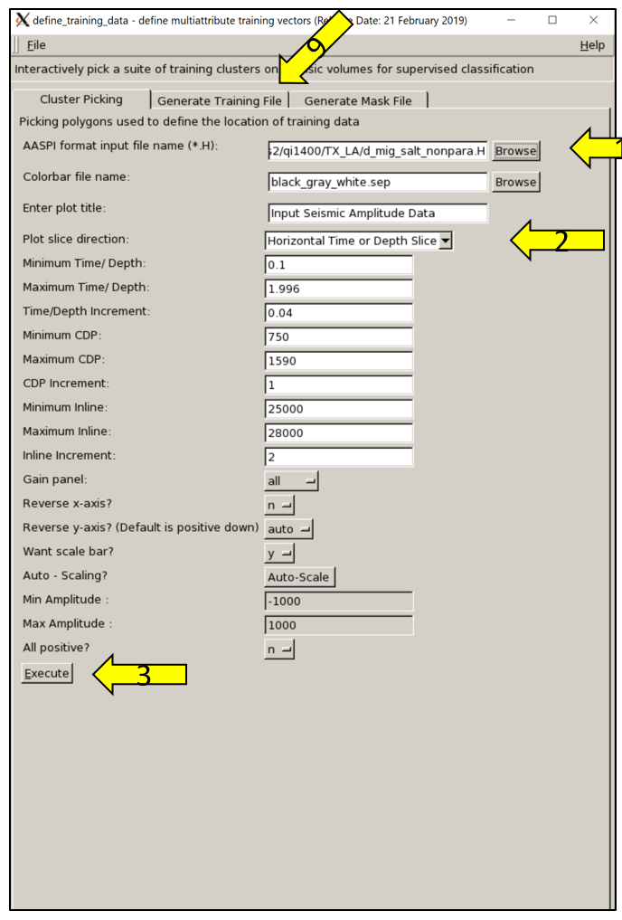
3
2
1
8

In using define_training_data, we can use seismic amplitude or attribute volume to draw polygon. (1) Select seismic amplitude or attribute volume, we can either plot (2) a time slice or a vertical slice to draw polygon if we want to change plot direction. Finally, click (3) Execute, then a plot will pop-up.
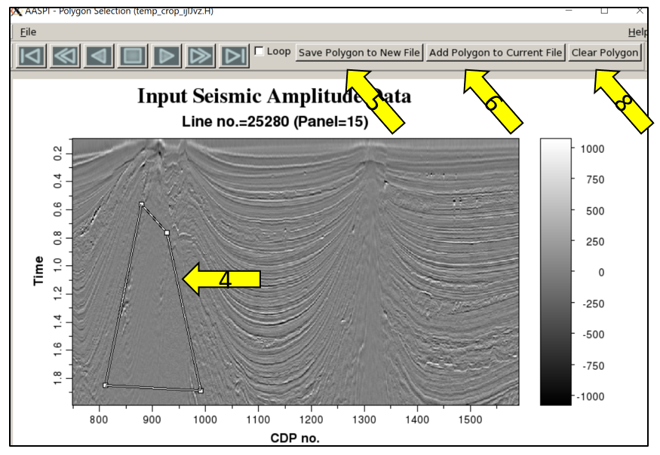
7
7

After plotting the inline slice, we (4) define a polygon around one of the two salt features. We then (5) need to click Save Polygon to New File. To define a second polygon about the same salt facies on the same or other slice we simply draw it and then (6 and 7) click Add Polygon to Current File.

After having completed defining the training data for the first facies on multiple slices, we need to change the polygon name in the project folder. Here and we change the default name polygon to be polygon_salt. Before picking another facies, we need to (8) click clear polygon, before drawing polygons for the next seismic facies.

Next, click Generate Training File in the define_training_data module. The window will change in order to extract the training data within the picked polygons. We select (9) the input picked facies (salt, MTD, background sediment) as well as (10) the input candidate attributes. Be sure to remember the input orders of facies and attributes because this information will be used in attribute selection. Finally, (11) click Execute after which the supervised 1D volumes within picked facies associated with different candidate attributes are generated. We have three facies and 9 attributes, resulting in a total of 27 input volumes. The first number in the name indicates the index of the facies, and the second number in the name indicates index of the attribute.

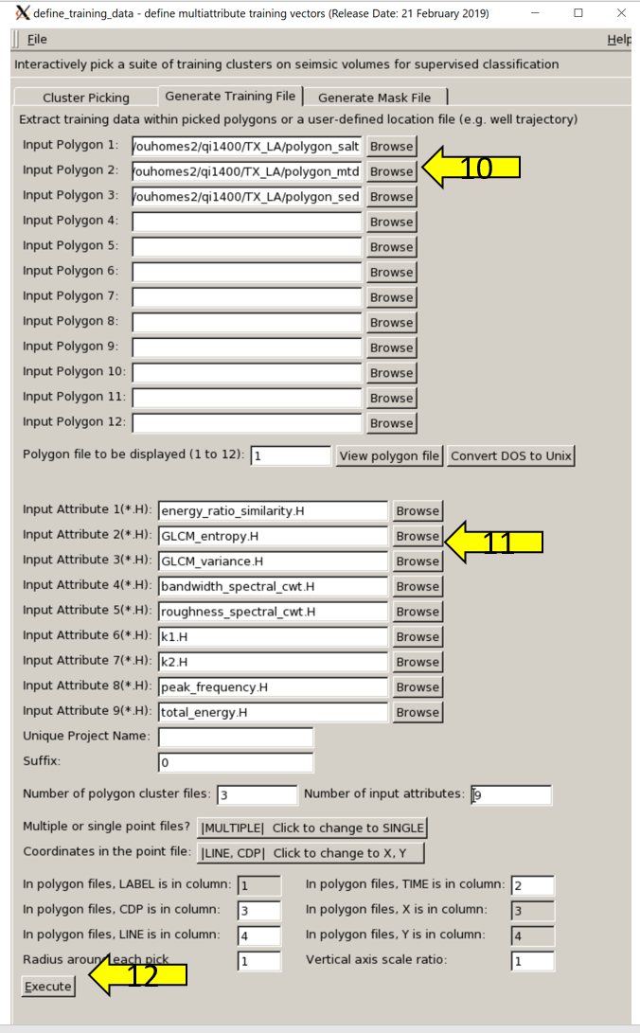
9
10
11

Now, in the attribute_selection module:

Click the (1) Browse and add to current list tab to select 1D volumes generated from define_training_data. Define (2) the Number of attributes to be used and (3) the Number of seismic facies. Then, (4) define how many GMM clusters are generated through expectation maximization algorithms, for chaotic facies, there are in general more than one cluster. Next (5) select whether or not to use stochastic expectation maximization. Finally, (6) click Execute Attribute Selection.

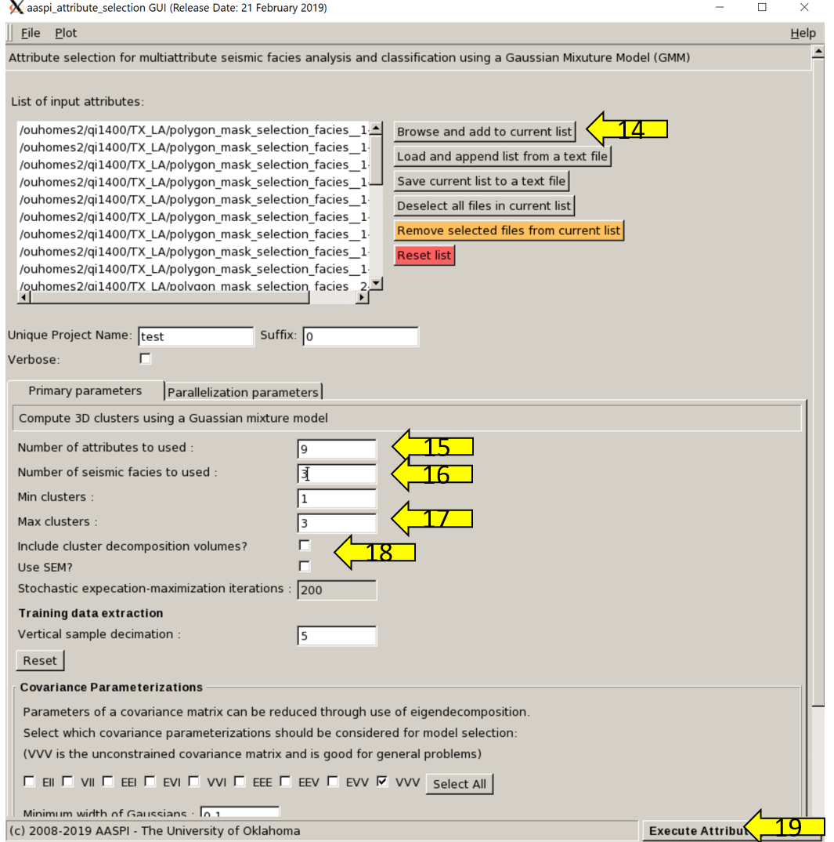
6
4
5
3
2
1

Attribute selection results

Details of this workflow can be found in Qi et al. (2019).

We first validate our attribute selection workflow by applying to the deep-water dataset that acquired from the Gulf of Mexico (GOM). The seismic data are located offshore Louisiana shelf edge and cover approximate 8000 km2 with 37.5 m by 25 m bins. Salt domes rise from the deep of basin, at where complex mass of shale and mud slides toward and deposits at minibasin. Multiple facies can be observed in the dataset, which include undeformed shale, interbedded sand and siltstone, salt domes, and mass transport complexes.
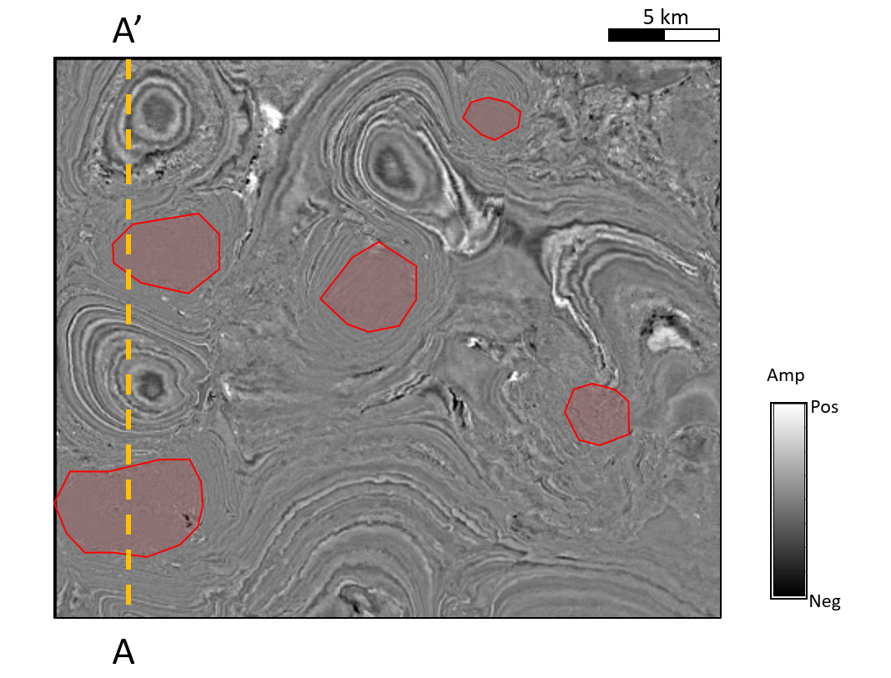
Figure 7.
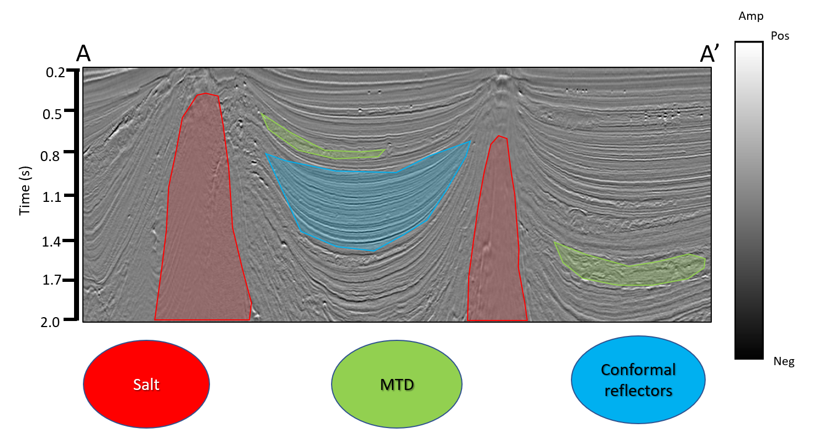
Figure 3. (a) Time slice at t = 1.22 s, and (b) vertical slice along line AA’ through the seismic amplitude volume. Red polygons indicate salt diapirs voxels that will be used to define the location of this facies in multiattribute space. Green polygons indicate MTD facies, and blue polygons indicate conformal reflectors. Salt facies exhibits weak envelope, low frequency, and deviating boundaries of the reflector dip. When defining training data, interpreters only pick those voxels in which they have the greater confidence.

Seismic amplitude played as the initial attribute in seismic interpretation is able to identify most of large geologic features by the spatial variation of seismic amplitude and phase. Other seismic attributes derived from seismic amplitude provide quantitative measure of statistical and geometric patterns of geologic features. Figure 3a shows the time slice at t = 1.22 s through the seismic amplitude volume. Figure 3b shows the line AA’ through the seismic amplitude volume. Note the polygons indicate the three picked facies of interest (M=3), which are salt diapirs, conformal reflectors, and MTD. Seismic expression of salt in the GOM data is vertically and laterally chaotic, and incoherent. Because the data is pre-stack time migrated, parts of reflectors such as boundaries of salt are mis-migrated and also able to be observed on salt diapirs. Seismic expression of MTDs is incoherent and chaotic as well, however MTDs exhibit mixed energy and frequency rather than low energy and frequency in seismic expression of salt. In the picked salt facies (Figure 4a), it contains mixtures of seismic noise that are incoherent subsequent facies, and migration artifacts that are coherent subsequent facies. MTD facies can also be seen coherent, rotated reflectors (Figure 4b), which are depositions of mudstone or siltstone blocks, or sliding gravity flows of shale formation. The zoomed conformal background is shown in Figure 4c and makes of coherent sediment and shale layers. Figure 5 indicates GMMs the MTD within two subsequent facies on the 2D attribute space.

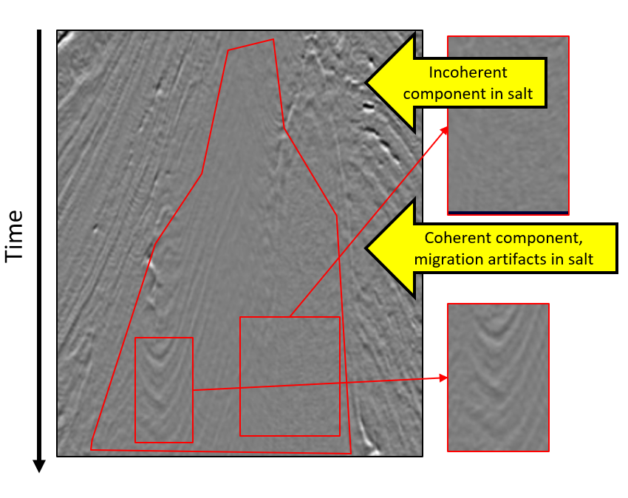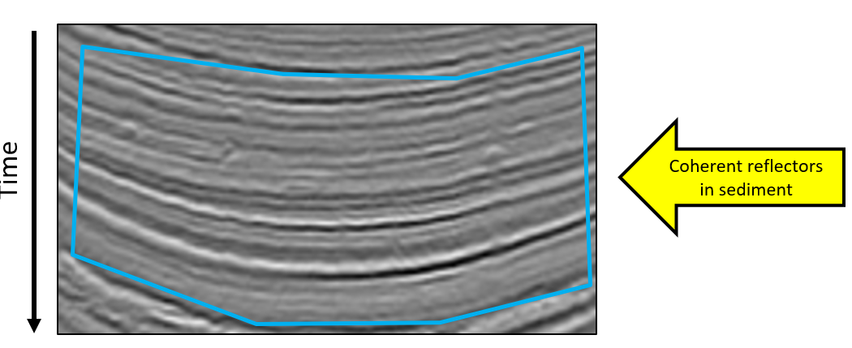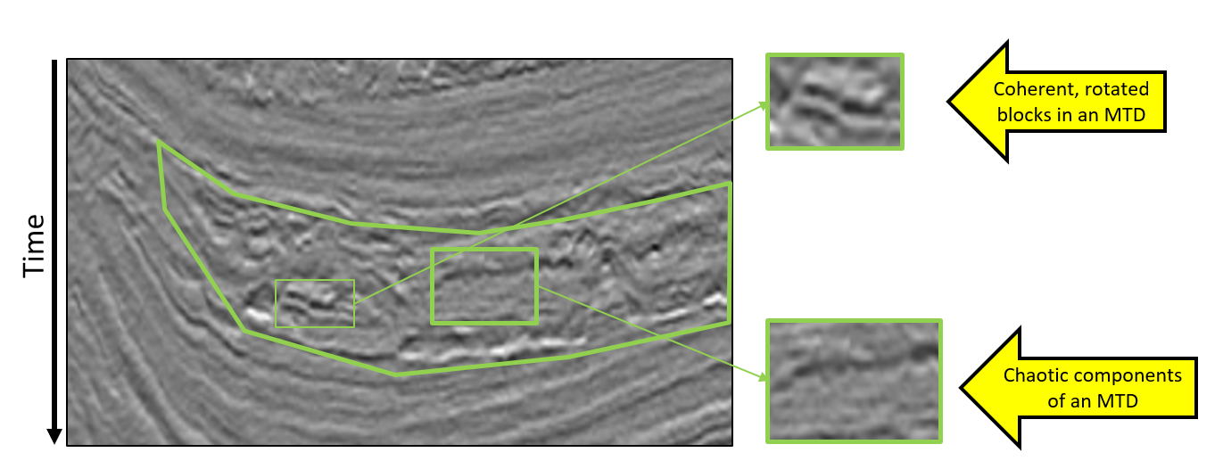
Figure 4. Zoomed vertical slices from Figure 5b of picked (a) salt, (b) MTD, and (c) conformal background facies. Note salt and MTD may contain coherent and incoherent subsequent facies.

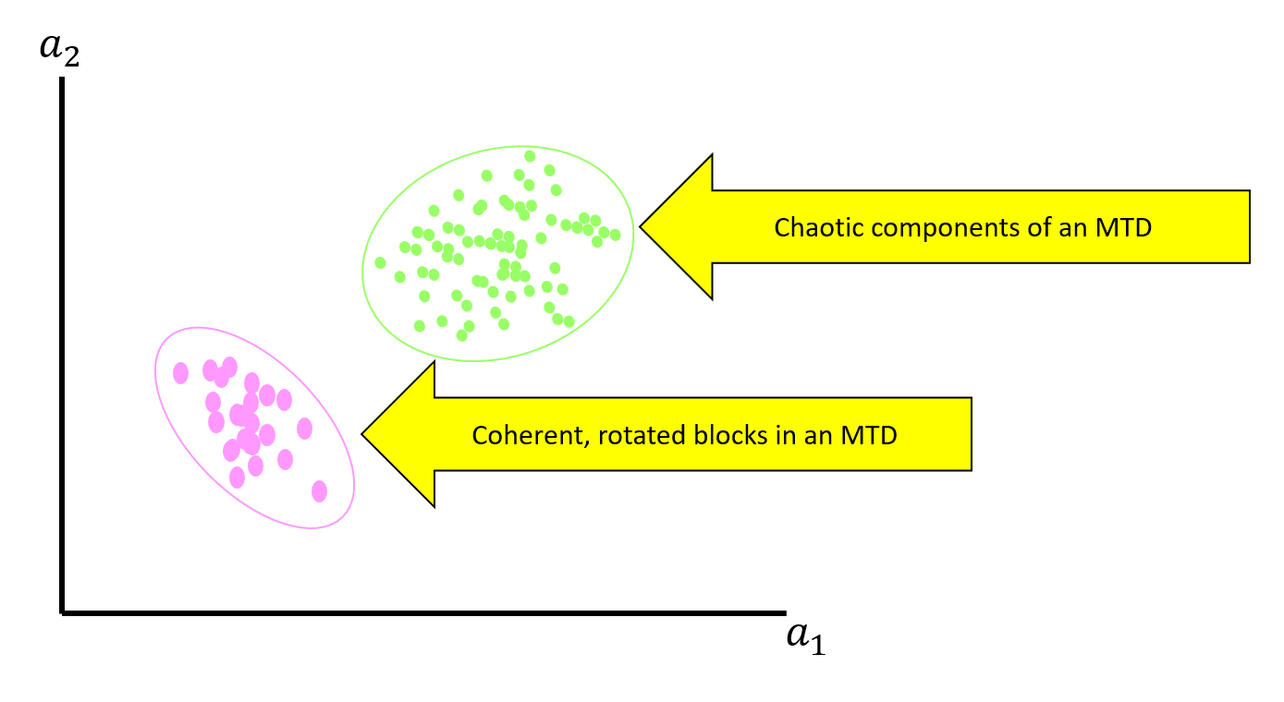
Figure 5. A cartoon of two GMMs represents chaotic components and coherent, rotated blocks in an MTD.

To avoid redundant use of attributes, we identify salt features of dip, amplitude, and frequency variation, through using the coherence, grey-level co-occurrence matrix (GLCM), nonparallelism attributes, and statistic measures of frequency, totally nine candidate attributes (N=9). The candidate attributes selected for the GTM should successfully measure different seismic responses of salt, conformal reflectors, and MTD. Figure 6 shows the list of the input candidate attributes. Note that the deviation of vector dip, the deviation of energy gradient attributes, and the covariance of vector dip and energy gradient highlight chaotic salt areas, high energy salt boundaries, and nonparallelism and randomness of seismic reflectors, respectively. The spectrum bandwidth attribute, and the spectrum roughness attributes belong to statistic measures of spectrum that are used to detect frequency variation between salt and other facies. Additionally, the spectrum bandwidth of salt rapidly changes and exhibits chaotic anomalies. The roughness of spectrum salt is much lower than other facies. These two statistic measures of spectrum describe the frequency variation of salt diapirs in two different ways.

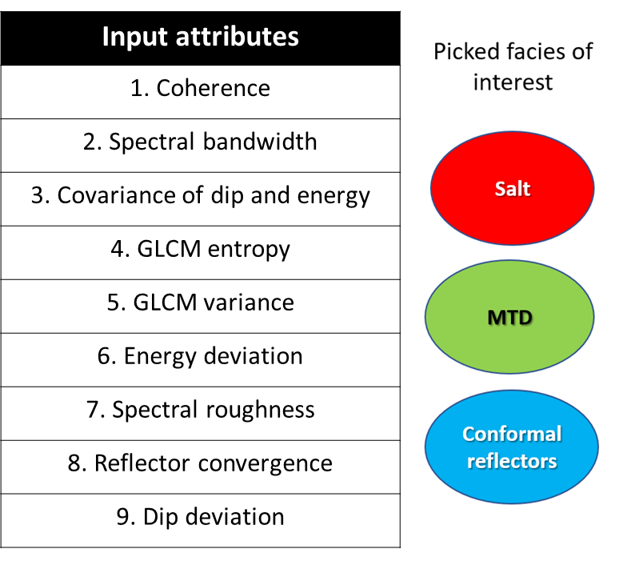
Figure 6. List of the candidate attributes and the picked facies of interest. Coherence measures the similarity between traces, which is also sensitive to strong random noise. Spectral bandwidth and spectral roughness are statistic measures of spectrum. GLCM entropy and GLCM variance are texture attributes and measure texture variations of seismic amplitude images. Dip deviation, energy deviation, and covariance of dip and energy measure lateral changes of reflector dip, lateral changes of reflector energy, and lateral changes of covariance of dip and energy. Reflector convergence measures vertical changes of reflector dip.

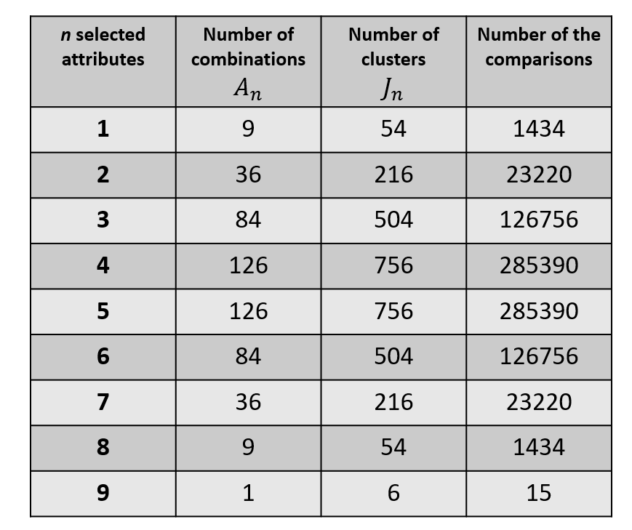
Figure 7. List of each N (N=1, 2, …, 9) selected attributes associated with the number of combinations, the number of clusters, and the number of the comparisons in each sub-group combinations.

Extracting the training voxels of the three picked facies from the nine candidate attributes is the first step of the attribute selection workflow. The total number of combinations about a nine-attribute combination is 511. For each combination of N selected attribute each facies m, we compute J GMM clusters. Different attribute combinations can have different numbers of GMM clusters. While “homogeneous” seismic facies like salt may be well represented by a single GMM, more heterogeneous seismic facies like MTD may require two or more GMMs. To decrease computation cost and the influence of seismic random noise, the maximum cluster number of each attribute combination each facies is set to two. The training voxels is generated to multiple GMMs. The subsequent combination number of each combination and the number of GMM clusters that associated with the subsequent combination number are shown on Figure 7. The Bhattacharyya Distance between each GMM cluster in each n selected attribute combination is computed to compare the similarity of each two-cluster pair of GMM. The number of the Bhattacharyya Distance computed about each N selected attribute combination is J!/(J-2)!/2!. Next, we compute the commutative distance to evaluate attribute combinations, then average the distance by the number of the sub-group possible combination, the number of picked facies, and the number of the computed GMM clusters in the identical number of the attribute space. Figure 8 shows the average cumulative distance of each possible number of selected attributes from the total nine attribute. The maximum distance is within the seven selected attributes and those attributes are coherence, spectral bandwidth, GLCM entropy, GLCM variance, energy deviation, spectral roughness, and dip deviation (Figure 9).
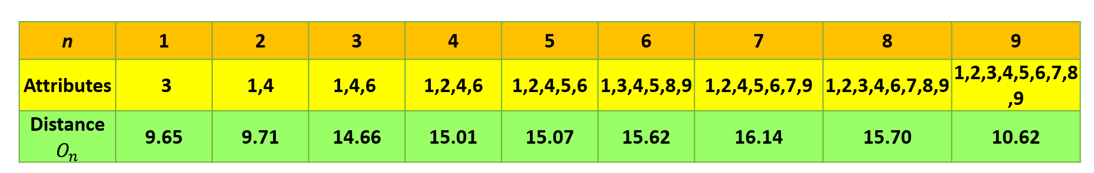
Figure 8. List of the average cumulative distance of each n selected attributes. Note that the attribute combination associated with the highest distance is 1, 3, 4, 5, 8, 9 (attribute index in define_training_data).

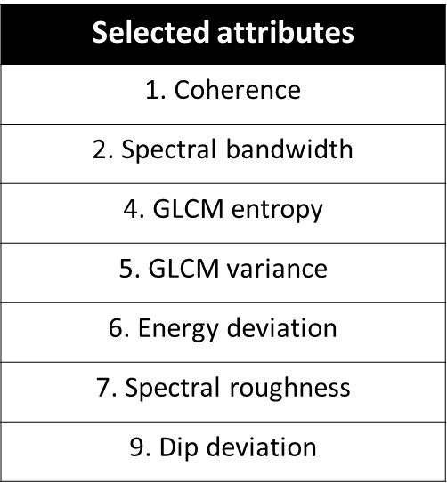

Figure 9. List of the attributes in the selected attribute combination.

Random Forest Decision Tree Classification– AASPI Program rfc3d

Random Forest is a supervised classification algorithm using multiple decision trees. Program rfc3d uses training data generated from facies interpretation or well log property and a number of seismic attributes as input. Output is predicted facies or class in 3D seismic volume. Attribute importance is a byproduct of the random forest algorithm, providing quantitative measure of how important or redundant each attribute is in the learning process. The program generates random forest model with training data and cross-validate the model. The accuracy and feature importance are displayed.

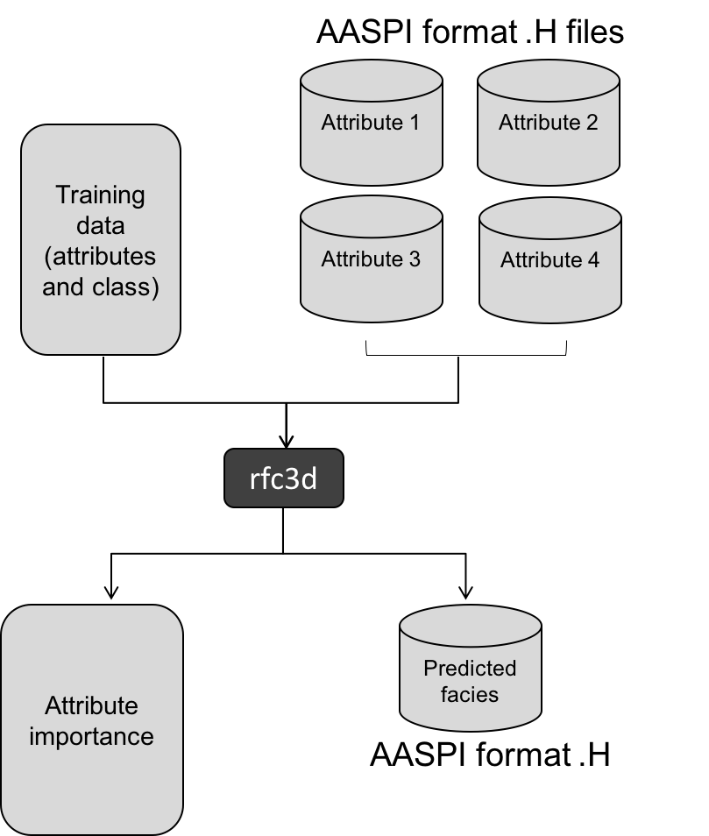

Figure 10. Workflow diagram of program rfc3d.

Single decision tree and random forests

Classification and regression tree (CART) is a machine leaning technique (Breiman et al, 1984), in which the best split is made using Gini impurity at each internal node in the tree given by:
$Gini i\left(τ\right)=1- \sum_{k=1}^{K}{p}{\left(k | τ\right)}^{2}$, (1)
where K is the number of classes, and p(k | τ) is the probability of class k at node t. The probability is the fraction of observations that belong to class I at node t. The leaves are the final outcome or class. Gini impurity is a measurement of the likelihood of an incorrect classification of new instance if it was randomly labeled according to the distribution of labels in the subset. Thus, possible minimum value of Gini impurity is 0, when all observations belong to one class.

Prediction for N number of trees can be made by averaging the prediction of individual trees and is given by
$i_{N_{T}}\left(τ\right)= \frac{1}{N_{T}}\sum_{T}{i\left(τ\right)}$. (2)

Feature importance

Selecting appropriate features is important in machine learning algorithms. Some features are more powerful for classification, and others may be redundant. Reduction of dimension based on feature selection can speed up the learning process, as well as improve prediction accuracy. To evaluate feature importance, Breiman et al. (2001, 2002) suggested Gini importance based on Gini index as impurity function given by
$Gini Importance i_{G}\left(θ\right)=\sum_{T}{\sum_{τ}{∆i_{θ}\left(τ,T\right)}},$ (3)
where, $∆i(τ)$ is node purity gain which is denoted
$∆i\left(τ\right)=i\left(τ\right)- p_{l}i\left(τ_{l}\right)- p_{r}i(τ_{r})$. (4)
A decrease in Gini impurity, $∆i(τ)$ results from splitting the samples to left and right sub-nodes.
Single decision tree example. A tree is composed of a root node, internal nodes, and leaf nodes. The first split is made in the root node after an attribute of dataset is randomly chosen. The process repeats splitting training set in internal nodes until it reaches leaf nodes when the node meets maximum depth or no more split can be made. Finally, the subset in leaf nodes returns class or label.

Program rcf3d is launched from the Volumetric Classification in the main aaspi_util GUI:
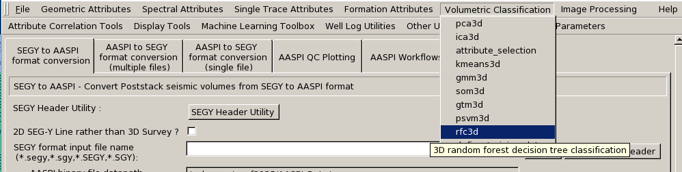

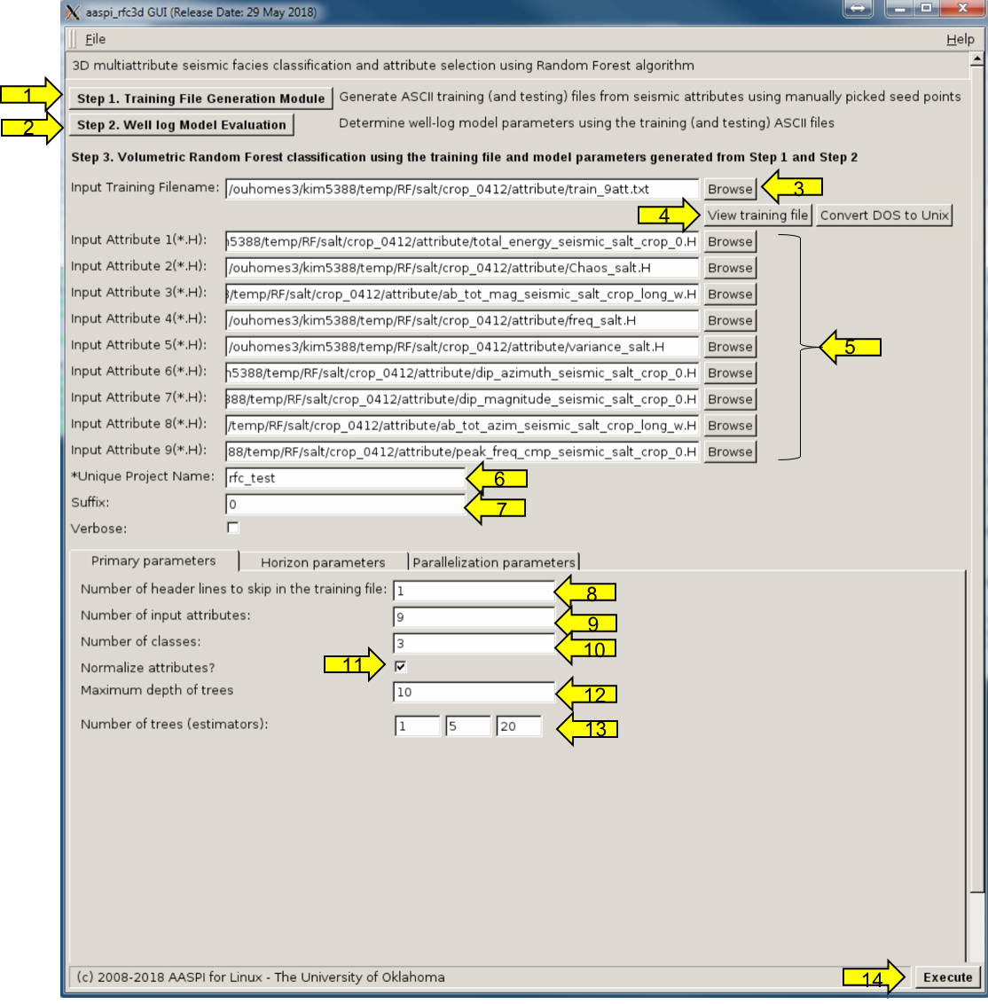
14
13
12
11
10
9
8
7
6
5
4
3
2
1

The program rfc3d requires training file and multiple attributes as input. Training data can be generated with (1) either manually picked facies, or (2) property interpreted from well logs. In this example, we manually selected the seismic facies of interest using the define_training_data module defined previously

After the user picked the target seismic facies, click (3) the Browse tab, and select a text-format training file. To check the text file, click (4) the View training file tab. Then (5), choose AASPI format *.H attribute files as inputs for facies classification. The output file is the same seismic volume as an input attribute format. As always define the (6) Unique project name and (7) Suffix.

Next, (8) define the number of header lines you want to skip in training file. Then (9) select the number of input attributes. Note that the default value is updated when new attributes are added. (10) Type the number of classes in training file. (11) Toggle on Normalize attribute if scaling of each attribute is needed.

(12) Define the Maximum depth of the trees, and (13) the Number of trees (estimators) which are hyper parameters related to the random forest algorithm. Higher maximum depth results in a more complicated tree model that might cause overfitting. The random forest algorithm is an ensemble method using Bootstrap aggregation (Bagging). The method combines multiple decision trees, which enhance the accuracy of prediction. The higher number of estimators increases accuracy up to a certain point, but also increases the amount of computation. The program tests three cases of number of trees and adopts the best number of trees as parameter for facies prediction. Finally, (14) click Execute to start the program.

Program rfc3d displays the result of five-fold cross-validation of random forest model. After testing the different number of trees, the tree number which exhibits the best accuracy is adopted for prediction. Using the RF model generated from training data, attribute importance is evaluated, and normalized importance is printed.

Program rfc3d will always generate the following output files:

Output file description | File name syntax
Random forest prediction | rfc3d_classification_unique_project_name.H
Parameter information | aaspi_rfc3d_unique_project_name.out

Random Forests results

Results for the random forest decision tree classification can be found in a paper by Kim et al. (2019).

Figure 11. A representative time slice through seismic amplitude (left) and predicted class (right). The prediction was made with RF algorithm using 9 attribute volumes. The area indicated with red line in left images have chaotic and discontinuous seismic expression, which is interpreted as mass transport deposit.

References
Breiman, L., 2001b. Random forests: Machine Learning 45, 5–32.
Breiman, L., J., Friedman, C. J. Stone, and R. A. Olshen, 1984, Classification and regression trees: CRC press.
Celeux, G., and G. Govaert, 1993, Gaussian Parsimonious clustering models: Pattern Recognition, 28, 781-793.
Hardisty, R., 2017, Unsupervised seismic facies using Gaussian mixture models, Master’s thesis, The University of Oklahoma
Kim, Y., R. Hardisty, and K. Marfurt, 2019, Multivariate attribute selection in seismic facies classification: 89th Annual Meeting, SEG, Expanded Abstract, 2258-2262.
Kingma, D., and J. L. Ba, 2015, Adam: A method for Stochastic Optimization: 3rd International Conference for Learning Representations, 1-15.
Mak, B., and E. Barnard, 1996, Phone clustering using the Bhattacharyya distance, Proc. Int. Conf. Spoken Language Processing, 4, 2005-2008.
Masters, T., 1995, Advanced Algorithms for Neural Networks.
Qi, J., T. Ha, B. Lyu, D. Lubo-Robles, and K. Marfurt, 2019, Seismic attribute selection for machine learning based facies analysis: 89th Annual Meeting, SEG, Expanded Abstract, 1853-1857.
Qi, J., T. Lin, T. Zhao, F. Li, and K. J. Marfurt, 2016, Semisupervised multiattribute seismic facies analysis: Interpretation, 4, no. 1, SB91-SB106, doi: 10.1190/INT-2015-0098.1
Schwarz, G., 1978, Estimating the dimension of a model: The Annals of Statistics, 6, 461–464

